The Behavioral Economics of ageing: expectations, planning and loneliness

The United Kingdom is facing an increasing ageing population resulting from a combination of the factors, including post-war baby boom, ‘echo’ baby boom and individuals living longer. (ONS, 2017) In the next 22 years, the percentage of population older than 75 years will be around 14%. (GOS, 2016). Ageing increases the risk for chronic diseases, disability, loneliness and cognitive decline, and is predicted to be a main driver in increase of public spending over the next decades (GOS, 2016). As such, the older population is increasingly putting pressure on limited financial and health resources. The Government has noted the ageing population itself will be important factor in United Kingdom’s (UK) future. Therefore, it is important to consider elements impacting individuals ageing, including expectations around ageing.

In order to provide policy recommendations to help address the ageing population, it is important to understand individuals’ expectations in ageing and how these expectations are formed. Individuals expectations of ageing include various elements including, including their projected health, level of activity, financial status (savings), life expectancy and loneliness. We will first analyse “What behavioral incentives contribute to loneliness in western societies?” with specific regards to loneliness and ageing. Next, we will analyse the formation of longevity expectations. Finally we will conclude with look at factors which impact financial expectations, such as retirement savings. By combining these elements, we propose to show the importance in evaluating ageing expectations and the multi-factoral analysis.

What behavioral incentives contribute to loneliness in western societies?

Abstract

**Introduction:** Persistent loneliness trends among the elderly in the United Kingdom (UK) has triggered concerns, especially with an ageing population compounding the problem. Although evidences are mixed, there are findings which suggest urban neighborhoods are more likely to cause loneliness compared to rural regions. Such evidence is against assumptions that urban environments have lesser likelihoods of social isolation, given higher population densities. With potential biases in place that may lead to such anomalies, the present study attempts to investigate the loneliness patterns among elderly people living in Wigan, a borough located in Greater Manchester, England and address biases that could be present to explain the results of our findings through literature review.

**Methods:** This paper examines self-reported loneliness amongst the over population, in each of the c200 Lower Super Output Area (LSOA) in Wigan. Population density and travel time to nearest town centre are both used as measures of how urban each LSOA is. An OLS regression is used, controlling for deprivation, crime and average age, within each LSOA.

**Results:** The relationship between living in an urban area and prevalence of loneliness among 65+ is found to be significant, but modest. An increase in travel time to nearest town centre is associated with a -0.00941PP reduction in loneliness. An increase in the population density by 1 person per KM^2 is associated with 0.0000293PP more loneliness.

**Discussion:** Densely populated urban environments may not address social isolation among elderly people, possibly due to the effects explained through the Socioemotional Selectivity Theory. Due to limited time perceptions, elderly people limit relationships to only those that bring emotional fulfillment. Urban alienation experienced by the elderly as a result of growing distances from society and societal disintegration also give rise to loneliness. Services that help alleviate loneliness among elderly in urban areas may be not be as effective as envisaged due to prevailing stigmatisation. Other explanations of loneliness include the fragmented nature of families and deprivation causing social marginalisation of the poor.

**Policy Recommendations:**

This paper recommends policies that focus on behavioral risk factors related to loneliness. These include:

* Shared lives and Homeshare
* Interventions that encourage volunteering
* Interventions that promote strong and vibrant communities
* Interventions that destigmatise loneliness

Introduction

Loneliness statistics among elderly living in the United Kingdom (UK) has not improved since the past decade, with approximately 8% of people above 50 years old living in England reporting feeling often lonely, translating to around 1.4 million people (Age UK, 2018). Although loneliness trends have been stable, an ageing population in the UK compounds the problem, with people aged above 50 years old in England feeling often lonely projected to reach just above 2 million people by 2025 to 2030. Such scales are a cause for concern as it threatens individual wellbeing and future healthcare expenditure.

Many studies have demonstrated the hazards of loneliness, giving rise to greater dependency on health and social care services like increased visits to the general practitioner and earlier use of residential care (Gerst-Emerson & Jayawardhana, 2015, Russel et al, 1997). Loneliness reduces daily living activities by more than 50% and increased mortality risk among elderly (Perissinotto et al, 2012), which is equivalent to smoking 15 cigarettes daily (Marmot et al, 2016). Both physical and mental health suffer as a result of loneliness, registering higher risk of coronary heart disease, stroke, depression, anxiety and Alzheimer’s disease (Holt-Lunstad et al, 2010; Wilson et al, 2007; Valtorta et al, 2016; Beutel et al, 2017). Despite many past studies and policy papers recommending various measures to combat the issue, significant positive impacts are still unobservable, thus prompting further work into this area.

Loneliness is defined as a personal subjective sense of lacking and being deprived of socially desirable contacts to share social and emotional experiences (Victor et al, 2005; Age UK, 2014). This mismatch in actual and desired contacts highlights the importance of quality over quantity of relationships for an individual. According to Age UK, many factors are associated with loneliness as age progresses, such as gender, ethnicity, living arrangements, health, income and sexual orientation. Some factors are shrouded with uncertainty as findings reveal mixed results. One of these factors in particular is geography. Loneliness is often associated with social isolation, which is an objective state of having minimal contact with other people (Wenger et al, 1996). This association is linked to the argument that urbanisation helps in reducing the chances of loneliness among elderly, given social isolation is usually a problem in rural regions (Hart, 2016). However, findings have been mixed between the rural and urban divide (Age UK, 2014), suggesting that factors other than social isolation could be in place.

Context

According to the English Longitudinal Study of Ageing (ELSA), 84.8% of respondents live in urban developments and townships whereas only 15.2% live in villages and hamlets (Iparraguirre, 2016). Based on these estimates of elderly distribution, if the loneliness tally is proportional to the pattern of distribution, it is plausible to posit that there could be more lonely urban elderlies compared to their rural counterparts. A Welsh study found urban elderly reporting significantly higher levels of loneliness compared to rural peers (Jones et al, 1985). Older people living urban areas that are deprived or have higher crime rates have higher likelihoods of being lonely. (Scharf et al, 2002).

However, such an argument may be challenged with the notion that densely populated regions should promote more social interactions and reduce social isolation. A study in the United States found that elderly people in rural areas had lower Health Related Quality of Life (HRQOL) and were more socially isolated compared to urban dwellers (Baernholdt et al, 2012). Logically, opportunities for social interaction are likely to be more limited in more isolated and remote residential locations like rural regions. Furthermore, rural regions are at a disadvantageous position as they lack services such as good transport links and amenities that promote social interaction (Hart, 2016). This makes urbanised environments a more compelling and preferable option for elderlies to reside. Nevertheless, it is difficult to predict the effects of residential location on loneliness given there is still little direct research on comparative rates of loneliness between urban and rural locations in UK (Gerst-Emerson & Jayawardhana, 2015).

Given the complexities of geographical location in influencing loneliness, the following study attempts to investigate the loneliness patterns among elderly people living in Wigan, a town located in Greater Manchester, England, whereby the prevalence of loneliness will be compared between those living nearest and furthest away from the town centre. Moreover, the study will also address biases that could be present to explain the results of our findings through literature reviews, paying attention to factors contributing to loneliness in a particular locality and reasons why elderly people continue staying put, despite feeling lonely.

Method

Data used

Data is taken from Wigan Council. The dependent variable in this paper is a measure of loneliness for older people. Data on loneliness is take from the Wigan Council Open Data website. The measure of loneliness is the percentage of the over 65 population that are lonely. Data is analysed at the Lower Super Output Area (LSOA) level. There are 200 LSOAs, containing 1500-2700 people, with a mix of urban and rural areas.

This paper considers several independent variables that could be associated with loneliness. The primary question being considered is the relationship between urbanisation and loneliness. The density of the population, the distance to the nearest town centre are both used as proxies for how urban the area is.

There are a number of additional independent variables included in this analysis, for the purpose of gaining a more complete picture of the factors that affect loneliness, as well as reducing omitted variable bias. These include: crime, deprivation and average age.



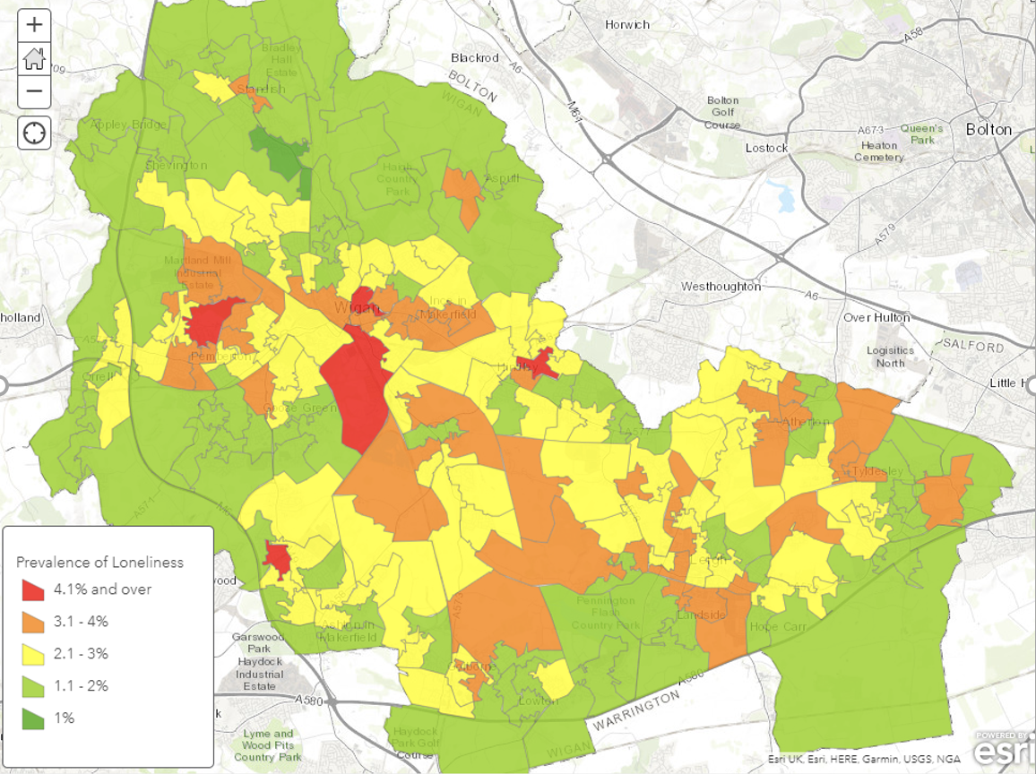

Results

Below is a table of summary statistics, including: the dependent variable (loneliness) and independent variables (Travel time, crime, deprivation, average age and population density). Levels of reported loneliness were very low, suggesting that quite an extreme measure of loneliness was used (e.g. “number of people who report feeling constantly/very lonely”).



In Model 1, an increase in travel time to nearest town centre is associated with a -0.0497PP reduction in loneliness. This rises to -0.00941PP in Model 3 (with controls), suggesting that Model 1 is negatively skewed. In Model 3, the LSOA furthest from a town centre is to have 0.268PP less loneliness amongst over 65s, compared with the LSOA closest to a town centre. In actual fact, loneliness is 3.65PP high in the loneliest LSOA than the least lonely, so this model does not explain a significant portion of variation in loneliness. Travel time to the nearest town centre is of limited usefulness as a measure of how urban an area is. Some individuals in the suburbs of a city (in this case Wigan) are in a more urban area than individuals who live near the centre of a small town. However, they live in an area that would be considered to be more urban. Population density is for this reason believed to be a better proxy for urbanisation.

In Model 4, an increase in the population density by 1 person per KM^2 is associated with 0.000094PP more loneliness. This reduces to 0.0000293PP in Model 6 (with controls). The least densely populated LSOA is predicted to have 0.263PP lower prevalence of loneliness amongst 65+ compared with most densely populated LSOA. The fact that these ranges are similar for Model 3 and Model 6, with two different measures of urbanization, supports the robustness of the finding that loneliness amongst over 65s is more prevalent in urban areas.

Deprivation is significantly negatively correlated with loneliness amongst over 65s. Average age and crime were not significantly correlated with loneliness in either Model 2 or Model 4. The R^2 in Model 4 and Model 6 is large (0.741 and 0.746 respectively), whereas in Model 1 and Model 4 it is much smaller. This suggests that urbanisation on its own does not explain much of the variation in loneliness, but urbanisation and deprivation combined explain a large portion of the variation in loneliness.

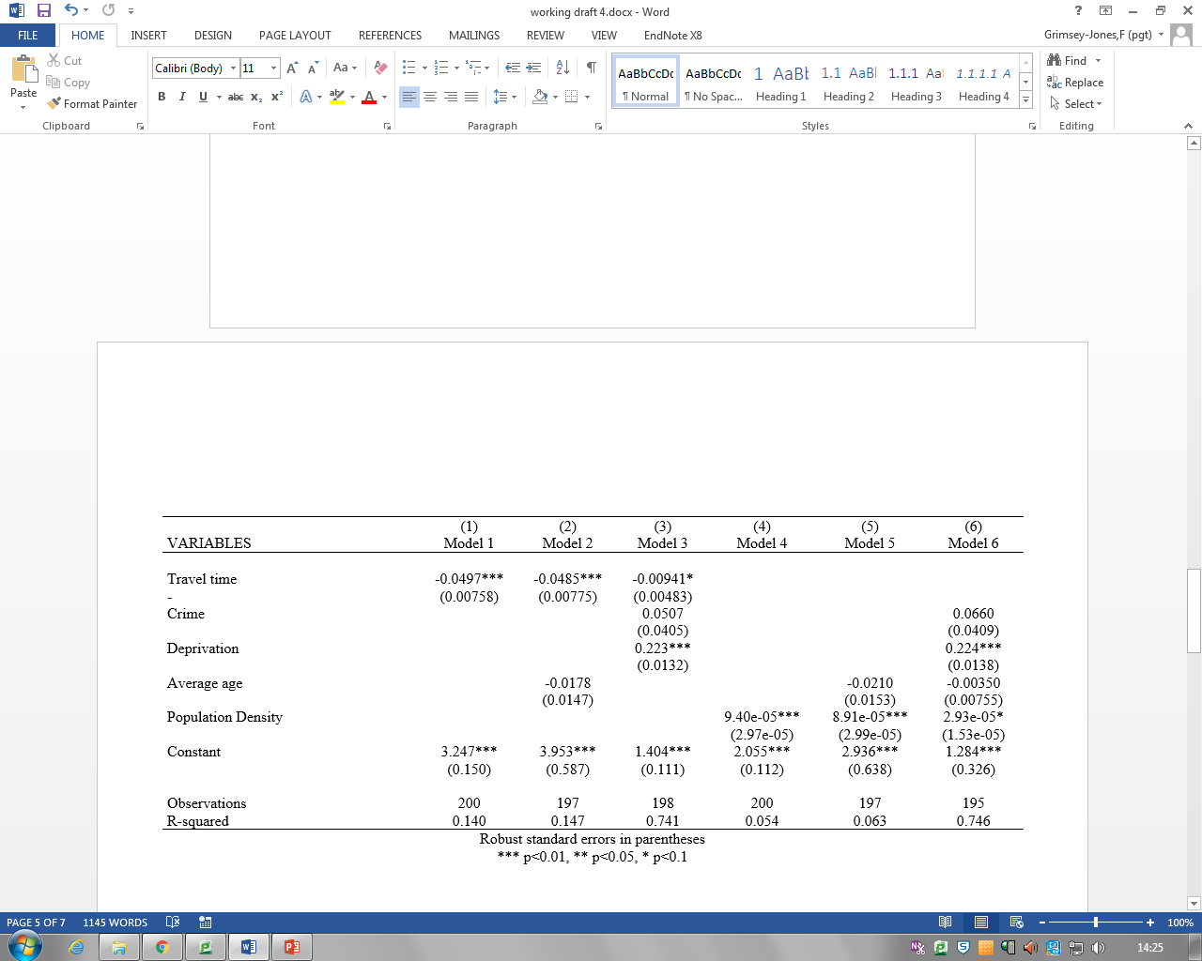

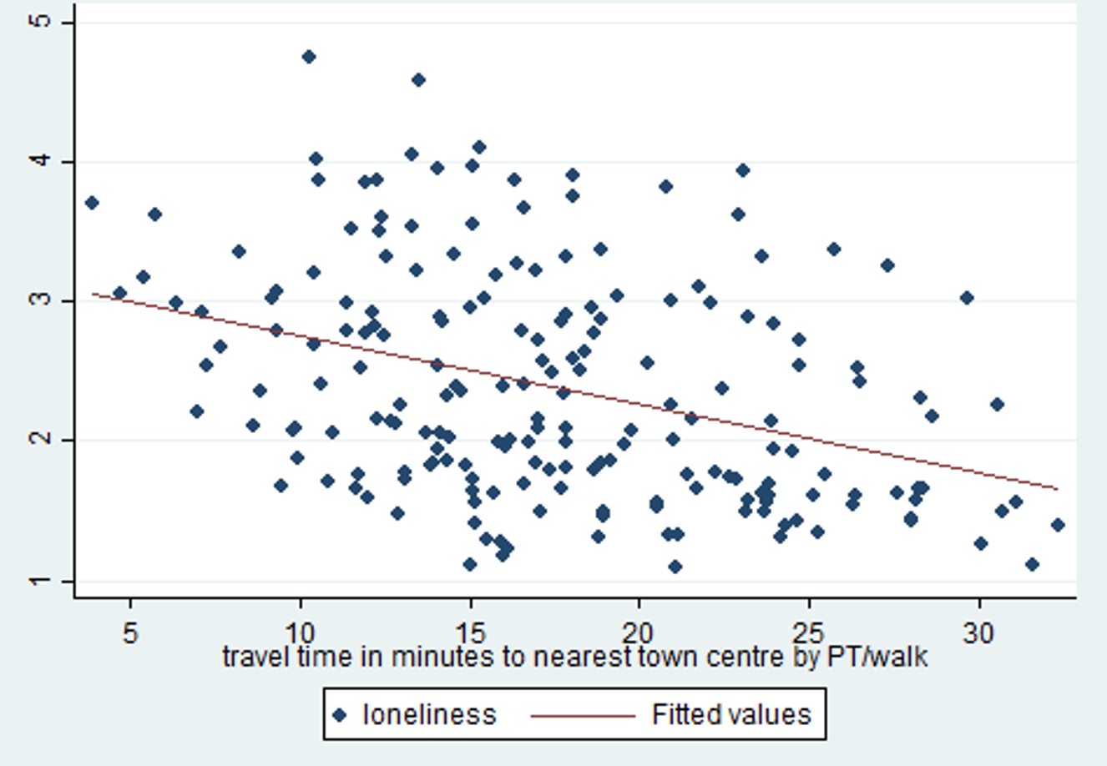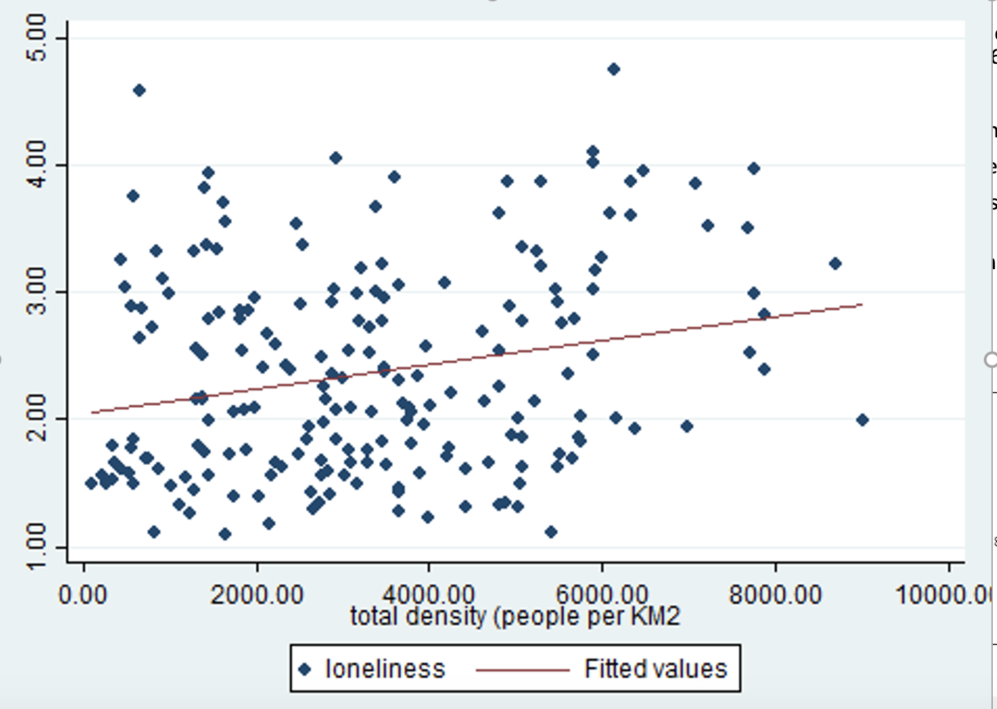

Discussion

On the basis of the results, there is some evidence that loneliness among older people is more prevalent in urban areas. However, the effect size appears to be modest. Whilst simple models suggested a large impact of living in an urban area on loneliness, models that include controls suggest a much smaller impact. Across models with a range of specifications, the relationship between urban dwelling and loneliness was found to be significant at the 5% level.

Densely populated regions have higher prevalence of loneliness among the elderly in the Wigan vicinity. Such findings opposes findings from other studies that sparse population densities led to higher rates of elderly loneliness due to social isolation (Hart, 2016). Behavioral psychology studies that study social patterns among elderly people may explain such anomalies in urban environments. The Socioemotional Selectivity Theory was proposed to explain the change in social interaction behaviour by people transitioning to old age (Löckenhoff & Carstensen, 2004). The theory suggests that with aging, time is cognitively perceived as a limited resource, which shifts social goals from being knowledge orientated for prospective utility investment, to that of fulfilling emotional needs. This motivates an elderly to become increasingly selective with who they will invest their time, effort and resource to socialise. This selectivity biases towards maintaining rewarding and positive relationships, such as family, close relatives and friends, while not prioritising other relationships. Experimental psychology studies also demonstrated cognitive changes among elderly led to self-bias towards close friends by increased inclusion of a friend in one’s self, which dictates changes in social behavioural attitudes (Sui & Humphreys, 2017). Such behavioural bias explains decreases in the amount of social interaction observed among elderly people, thus promoting social isolation even when living in a densely populated environment.

Urban alienation experienced by elderly people may also explain the effects of urbanisation induced loneliness. A recent qualitative study revealed that elderly people felt alienated due to a growing distance between them and society, both in terms of physical and social environment (Wong et al, 2017). This gap exists due to the time dependent transformation of culture and activities, triggering feelings of disconnection from the younger generation. The elderly also feel disintegrated from society in response to having an inferiority complex through perceptions of losing a functional role in society, which weakens their presence.

Although urban areas offer more services to alleviate loneliness among elderly residents, studies have shown that these services may not be as helpful as envisaged. Community centres catering to general social activities, may not be desirable by elderly people. Reasons cited for this discrepancy lies with the negative emotional exposure while socializing with other elderly people who share morbid old age issues (Sixsmith & Sixsmith, 2008). Moreover, services that help alleviate loneliness among elderly which are usually operated by the younger generation such as call centres or meet ups do not get much attention. Such cold responses are due to the belief that reaching out to such services suggests desperation, or it may induce shyness or uncomfortable feelings. A study showed that 1 in 3 people were found to be embarrassed to admit that they were lonely (Griffin, 2010). Such stigma may be a barrier that restricts elderly people to seek care or services that free them from loneliness.

Another possibility of loneliness could be due to the fragmented nature of families. According to a UK report, 42% of older people live alone and this proportion rises to 72% for populations aged above 85 years old (WVRS**,** 2012). About 12 to 15% of elderly people in UK have their children staying more than 40 miles away, which limits the frequencies for visits. Living alone promotes loneliness, with effects being amplified with age related losses of family and friends plus increases in frailty. Interestingly however, contrary to the logical perception that it would be better to enter a residential or nursing care which provides more social inclusion compared to living alone, studies have demonstrated institutionalization aversion among the elderly (Costa-Font, 2017). Such behaviour stems from biases towards ageing in place, such as having feelings of attachment and wanting to preserve social ties within the boundaries of home, providing a sense of independence, privacy and autonomy, while also being a more cost effective option compared to moving into an institution (Sixsmith & Sixsmith 2008, Sixsmith, 1990).

Elderly people residing in a deprived urban have higher likelihoods of being lonely (Bolton et al, 2012). According to reports by ELSA, a correlation that spans all age groups exists between wealth and loneliness (Demakakos et al, 2006). Loneliness rates were reported to be at least more than double for poorest respondents as compared to their wealthier counterparts. Such findings have been attributed to strong correlations between poverty and social isolation (Eckhard, 2018). Uncertain financial resources limit the capacity of individuals to sustain or initiate personal relationships. Moreover, belonging to a poor socioeconomic status fosters feelings of shame and inferiority towards the general public, thus inducing social withdrawal. Being poor also leads to unaffordability of home care and specialised services which may serve to promote social interaction (Klinenbeerg, 2016). Such negative effects result in social marginalisation of deprived classes in an urban society.

Policy recommendations

A number of interventions exist to promote social contact for older people. These include the pensioner’s bus pass, community transport and direct payments in order to allow people to access the community (Age UK, 2018). This paper suggests that increasing opportunities for social contact does not necessarily mean reduced loneliness. In urban areas there are more opportunities for socializing, better transport, shorter distances to see other people and yet more loneliness amongst the elderly.

Additionally, this paper suggests that loneliness is based on building deep emotional connections. Therefore interventions that promote positive social relationships may be more effective. A number of social care interventions exist that encourage vulnerable people to live with other people that are not elderly or vulnerable. One example is Shared Lives, where an individual lives a small community of vulnerable people and provides then with low level care. Each of the people receiving care has their own tenancy, allowing them to maintain autonomy (Shared Lives, 2018). Another example is Homeshare, in which an individual moves into the home of an older person and provides them with support in exchange for reduced rent.

Another intervention involves promoting volunteer based programmes that engages elderly people to participate in constructive community outreach activities (MacLeod et al, 2018). Such programmes foster socialization among elderly community members to counter social isolation. Being involved in productive projects also reduces urban alienation as they are empowered to have a social presence within the society, being able to contribute and make a difference for community.

Lastly, promoting a societal change that shifts stigmatization away from loneliness away sends a message to elderly people that being lonely is a normal occurrence and shameless to address. Removing stigma entices elderly people to be comfortable in seeking help and company. Efforts to reduce stigmatization and increase cohesiveness among society may be developed through public awareness campaigns and supporting local relationship enhancing programmes in Wigan, especially in deprived areas, to help build social capital within the urban community (Department for Digital, Culture, Media and Sport, 2018).

Bibliography (Topic 1)

Age UK. (2014). Evidence Review: Loneliness in Later Life. White Paper, (July), 1–29.

Age UK. (2018). All the Lonely People: Loneliness in Later Life, (September), 1-13.

Age UK. (2018, July 17). AGE UK. Retrieved from Personalised Care Budgets: https://www.ageuk.org.uk/information-advice/care/paying-for-care/financial-assessment/personal-budgets-and-direct-payments/

Age UK. (2018, October 31). Age UK. Retrieved from Free bus pass and transport concessions: https://www.ageuk.org.uk/information-advice/money-legal/benefits-entitlements/free-bus-pass-and-transport-concessions/

Baernholdt, M., Yan, G., Hinton, I., Rose, K., & Mattos, M. (2012). Quality of Life in Rural and Urban Adults 65 Years and Older: Findings From the National Health and Nutrition Examination Survey. Journal of Rural Health, 28(4), 339–347.

Beutel, M. E., Klein, E. M., Brähler, E., Reiner, I., Jünger, C., Michal, M., Wiltink, J., Wild, P. S., Münzel, T., Lackner, K. J., Tibubos, A. N. (2017). Loneliness in the general population: prevalence, determinants and relations to mental health. BMC psychiatry, 17(1), 97.

Bolton, M., Bowling, A., Burholt, V., Cattan, M., Cacioppo, J., Holt-lunstad, J., Walker, A. (2012). Loneliness--the state we’re in: A report of evidence compiled for the Campaign to End Loneliness. Abingdon: Age UK Oxfordshire.

Costa-Font, J. (2017) “Institutionalization aversion” and the willingness to pay for home health care. Journal of Housing Economics (38), 62–69

Demakakos, P., Nunn, S., & Nazroo, J. (2006). Loneliness, relative deprivation and life satisfaction. In J. Banks, E. Breeze, C. Lessof, &J. Nazroo (Eds.), Retirement, health and relationships of the older population in England: The 2004 English Longitudinal Study of Ageing. London: Institute for Fiscal Studies.

Department for Digital, Culture, Media and Sport. (2018). A connected society: A strategy for tackling loneliness – laying the foundations for change.(October); 1 - 84. Retrieved from: www.gov.uk/government/collections/governments-work-on-tackling-loneliness

Eckhard, J. (2018). Does Poverty Increase the Risk of Social Isolation? Insights Based on Panel Data from Germany. Sociological Quarterly, 59(2), 338–359.

Gerst-Emerson K, Jayawardhana J. (2015). Loneliness as a public health issue: the impact of loneliness on health care utilization among older adults. American Journal of Public Health ;105(5):1013-9.

Griffin, J (2010) The lonely society; The Mental Health Foundation

Hart, J (2016). Older people in rural areas: Vulnerability due to loneliness and isolation paper. Rural England Research Project, 1–19.

Holt-Lunstad J, Smith TB, Layton JB. (2010). Social relationships and mortality risk: a meta-analytic review. PLoS Med;7(7)

Iparraguirre, J. (2016). Predicting the prevalence of loneliness at older ages. Age UK, 1–20. Retrieved from http://www.ageuk.org.uk/professional-resources-home/research/reports/health-wellbeing/predicting-the-prevalence-of-loneliness-at-older-ages/

Jones, D. A., Victor, C. R., & Vetter, N. J. (1985). The problem of loneliness in the elderly in the community: characteristics of those who are lonely and the factors related to loneliness. The Journal of the Royal College of General Practitioners, 35(272), 136-9.

Klinenbeerg, E.(2016). Social Isolation, Loneliness, and Living Alone: Identifying the Risks for Public Health. American Journal of public health, 106(5), 786-7.

Löckenhoff, C. E., & Carstensen, L. L. (2004). Socioemotionol selectivity theory, aging, and health: The increasingly delicate balance between regulating emotions and making tough choices. Journal of Personality, 72(6), 1395–1424.

MacLeod S, Musich S, Parikh RB, Hawkins K, Keown K , et al. (2018) Examining Approaches to Address Loneliness and Social Isolation among Older Adults. Journal of Aging and Geriatric Medicine,2:1,1-8.

Marmot, M., Oldfield, Z., Clemens, S., Blake, M., Phelps, A., Nazroo, J., Steptoe, A., Rogers, N., Banks, J., Oskala, A. (2016). English Longitudinal Study of Ageing: Waves 0-7, 1998-2015. 25th Edition. UK Data Service. SN: 5050

Perissinotto CM, Stijacic Cenzer I, Covinsky KE.(2012) Loneliness in Older Persons: A Predictor of Functional Decline and Death. Arch Intern Med, 172(14):1078–1084.

Russell DW, Cutrona CE, de la Mora A, Wallace RB. (1997). Loneliness and nursing home admission among rural older adults. Psychology and Aging, 12(4),574-89

Scharf, T., Phillipson, C., Smith, A.E. and Kingston, P. (2002) Growing Older in Socially Deprived Areas: Social Exclusion in Later Life, Help the Aged: London.

Shared Lives. (2018, December 8). Shared Lives Plus. Retrieved from Welcome to Shared Lives Plus: https://sharedlivesplus.org.uk/

Sixsmith, A. (1990). The meaning and experience of home in later life. In B. Bytheway, & J. Johnson (Eds.), Welfare and the ageing experience. Aldershot: Avebury.

Sixsmith, A., & Sixsmith, J. (2008). Ageing in Place in the United Kingdom. Ageing International, 32(3), 219–235.

Sui, J., & Humphreys, G. W. (2017). Aging enhances cognitive biases to friends but not the self. Psychonomic Bulletin and Review, 24(6), 2021–2030.

Valtorta, NK, Kanaan M, Gilbody S, et al (2016) Loneliness and social isolation as risk factors for coronary heart disease and stroke: systematic review and meta-analysis of longitudinal observational studies. Heart; 102, 1009-1016.

Victor, C; Scambler, S; Bond, J & Bowling, A (2005) The prevalence of, and risk factors for, loneliness in later life: a survey of older people in Great Britain in Ageing & Society 25: 357–375

Wenger, G.C., et al. (1996) Social isolation and loneliness in old age Review and model refinement. Ageing and Society, 16, 333-358.

Wilson RS, Krueger KR, Arnold SE, Schneider JA, Kelly JF, Barnes LL, et al. (2007). Loneliness and risk of Alzheimer disease. Archives of General Psychiatry, Feb; 64(2):234-240

Wong, A., Chau, A., Fang, Y., & Woo, J. (2017). Illuminating the Psychological Experience of Elderly Loneliness from a Societal Perspective: A Qualitative Study of Alienation between Older People and Society. International Journal of Environmental Research and Public Health, 14(7), 824.

WVRS (2012) Loneliness amongst older people and the impact of family connections. 1 – 19.

Topic 2

Aging and Expectations

Importance of Expectations

Expectations regarding ageing can help predict how well a person will age later in life. (Kotter-Gruhn et al., 2009). Positive expectations including increased satisfaction with better ageing and younger subjective age. (Kotter-Gruhn et al., 2009) (Prior, K., and K. A. Sargent Cox, 2014) (Rippon, I. and A. Steptoe, 2018). These positive expectations are associated with lower mortality and improved health and quality of life indicators. (Kotter-Gruhn et al., 2009) (Prior, K., and K. A. Sargent Cox, 2014) (Rippon, I. and A. Steptoe, 2018) (Andrews, R. et al., 2017) Conversely, individuals can experience negative health impact from when faced with negative images around ageing. (Prior, K. and K. Sargent-Cox, 2014) (Bardach, S., Gayer, C., Clinkinbeard, T., Zanjani and J. Watkins, 2010). In this way, it has been argued that ageing expectations could be viewed as self-fulfilling prophecies. (Kotter-Gruhn et al., 2009) (Prior, K., and K. A. Sargent Cox, 2014) We will look at two key variables in ageing: life expectancy and financial savings, and evaluate what behavioural learnings can be ascertained and perhaps leverage to improve overall ageing expectations and therefore overall ageing.

1. Life Expectancy

Life expectancy provides the temporal framework for individuals to plan other aspects of ageing, such as financial planning and housing. (Finkelstein, A. and K. McGarry, K., 2003). A person who anticipates dying before age 80 or 85 may save less for retirement than one who anticipates living to 90 years. Individuals who expect a shorter lifespan may also anticipate less need for long-term care, or less years with impact from age related health conditions or deterioration. It is important then to examine the accuracy of individual’s expected life span in relation to the current population estimates and how these expectations are formed.

First, we will examine the findings regarding life expectations, and the possible behavioral elements influencing the formation of these expectations. Then we will analyse data from the English Longitudinal Study of Ageing (ELSA) Wave 8 to evaluate whether there is possible evidence of behavioural elements on individual life expectancy.

Background

When individuals think of their future, they may be considering how well they will age (quality) and for how long (life expectancy). Research has found that individuals appear to have fairly reasonable expectations of their own life expectancy – meaning it is not significantly under- or over-estimated. (Costa-Font, J. and M. Costa-Font, 2011). Individuals become more optimistic with regards to life span, the closer they approach old age. (Costa-Font, J. and M. Costa-Font, 2011). Given the relative accuracy of life expectancy expectations, we will next look at what behavioural elements may be influencing this decision making, and calculation of life expectancy.

Evidence based on a longitudinal Korean study found that life expectation expectations seem to be relatively rational and aligned with Bayesian learning. (Pak, T., and Y. Choung, 2017) Bayesian Learning implies that individuals will re-evaluate the probability of an event in consideration of new information. Individuals will base their expectations, i.e. probability of events, based on known information and adjust their expectations based on any new information which would come to light. (Kahneman, 2011) (Pak, T., and Y. Choung, 2017) With Bayesian learning, we would anticipate that individuals would adjust their anticipated life span rationally with relevant information, such as health habits, including smoking or genetic (familial) history.

We put forth that life expectancy expectations may be the result of a combination of Bayesian learning, anchoring and availability bias. Anchoring is when an individual uses a reference point from which to estimate/weight the likelihood of an event or scenario. (Thaler, R.H., and C.R. Sunstein, 2009) Availability bias is when individuals place increased likelihood of event or situation occurring, the most easily it is recalled. (Kahneman, 2011) Individuals may anchor their initial life expectancy estimates based on the widely available, and often public, information about lifespans for a given population and gender. Life expectancy data is widely available and shared through multiple media outlets.

We will next evaluate whether there is further evidence for Bayesian learning connected to life expectancy by evaluating ELSA data related to life span expectations, smoking, and diabetes/high blood sugar.

Data Analysis and Discussion

For the analysis, we used ELSA Wave 8 data which was collected May 2016 to June 2017, and included 8,445 participants. (ELSA) We focused on variables included in the Wave 8 data. A proxy was used for life expectancy with the continuous variable EXLO90 which asked “What are the chances that you will live to be 85 or more?” (ELSA). Health information was measured for smoking and diabetes/high blood sugar; we used (1) variable HESKA, which asked if the individuals smoked cigarettes, though did not include electronic cigarettes, and (2) variable HEDACDI , “Whether confirms diabetes or high blood sugar diagnosis”.

The current life expectancy for males born in England is 79.5 years and for women is 83.2 years. (ONS, 2015). Though this variable asks expectations slightly greater than current life expectancy – this is a marginal variance and we are evaluating whether those with negatively associated health or familial health histories adjust their expectations downward.

The hypothesis is if individuals have and understand relevant health information, such as effects of smoking or high blood sugar, they may adjust their anticipated life expectations downward based on this information. In other words, frequent smokers would be aware of the health risks of smoking and anticipate being more likely to anticipate dying earlier than the non-smoking population.

Data was uploaded into Stata and linear regression performed - the results of which are below in Table 1. Both smoking and diabetes/low blood sugar have p values < 0.0000 and 95% confidence intervals which do not include zero. The r value is small, noting less than 3% of the variation in chances with live to 85 years is explained by variation in smoking or diabetes/blood sugar. For smoking, a change in smoking (yes/no) results in a 3.29 decreased in chances would live to 85 by 3.29. The effect is greater with diabetes/high blood sugar where a change in high blood sugar/diabetes, is associated with decrease of 4.454. in chances that will live to 85 years. These results indicate the individuals in the population may be (i) aware of their adverse health conditions, (ii) aware of the impact of these habits or conditions on their life expectancy, and (iii) adjust their life expectancy estimation downward with this information. Therefore our hypothesis has not been rejected that individuals are anchoring their life expectancy and then adjusted based on available information, applying Bayesian learning.

**Table. 1**

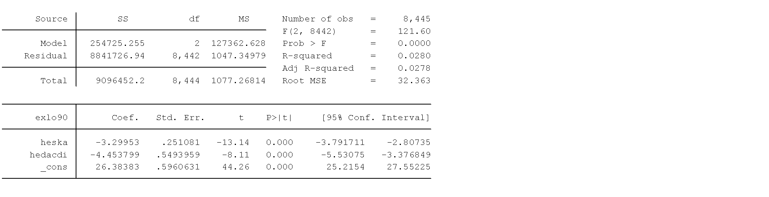

Limitations

Limitations of the data analysis include need for further analysis to take into account age and gender variations, especially in light of prior research indicating different expectations based on gender or proximity to old age. Both health conditions were self-reported which may lead to underreporting of health behaviors with negative associations to social norms. With regards to smoking, future research may wish to compare long-term smokers, age of smoker, and former smokers, to determine any impact on life span expectations. ELSA Wave 8 did not include any specific data on obesity, which may be correlated with diabetes, low blood sugar and perceived early mortality risk. Subjective questions on whether or not a person perceived themselves overweight may be useful, though data on either clinical diagnosis or body mass index could add value to future research. Lastly, further statistical analysis should expand on this initial linear regression model to test the robustness of the relationship and account for any interference.

Public Policy Implication and Conclusion

Individuals expectations regarding ageing can impact their planning for their future selves and in fact future health. Whether or not these expectations are accurate can then have consequential impact on the pressures both on the individual and society to support the ageing population. The fact individual expectations around life expectancy show Bayesian learning and understanding of impact of health related behavior on mortality, warrants further investigation by policy makers. If one can understand more about how, and importantly why, individuals more or less accurately form and possibly adjust life span expectations, then policy makers may be able to apply these learnings to other ageing expectations and achieve improved ageing in the population. Given the correlation between ageing expectations and future health, this is especially a key time for this analysis so that we can work to help the ageing population live longer, and better.

1. Long term Care and the Future Self

According to the Office for National Statistics (2018), “around 18.2% of the UK population were aged 65 years or over at mid-2017, compared with 15.9% in 2007; this is projected to grow to 20.7% by 2027” (Office for National Statistics, 2018)**.** Despite an ageing population the publicly funded social care programs in the UK are inadequately prepared. Indeed, in 2030/31 public social care will face an 18 billion funding gap (Thorlby, 2018, ). Due to an increase in utilization, the NHS has become increasingly strident on who is eligible for publicly funded social care. In 2018/19, despite an increase in the number of people requiring social care a diminishing number were deemed eligible based on the criteria. Within these increasing demands cost-shifting to the individual is likely. However, a majority of individuals are not privately saving for their retirement or future long term care costs. Indeed, based on one survey by Aaron (2010), only 35% of adults over 50 felt prepared for retirement and nearly all of those sampled had not thought about the costs of long term care or future medical care. While, many individuals aged 50-60 will have access to a pension at retirement a large portion of self employed or precariously employed individuals will not have access to these funds. These issues present a significant policy issue as those with insufficient savings will need to rely heavily on an overburdened social care system, potentially, threatening it’s sustainability.

To investigate factors that influence retirement saving I will be looking at survey data from the Eurobarometer study (2007). In particular, I will be exploring if an individual's experience as a caregiver positively impacts people’s intentions to save for retirement and long term care. I propose that previous experience as a caregiver reduces the psychological distance between the present and the future self and allows individuals to visualize themselves in old age and are thus, more inclined to save. In this essay, I will briefly discuss the theories surrounding retirement decision making, in particular construal level theory (CLT) and the future self. Then I will discuss the data I used for the study and my analysis. Lastly, I will present some potential policy initiatives that could be applied based on these findings.

**Background**

Retirement planning is unique compared to other decision making processes in that the decisions we make today affect us 30 or 40 years down the line. In addition to temporal distance, people must navigate complex information, confront issues of life expectancy and perceptions of risk . Past theories on retirement decision making have relied heavily on rational lifecycle models that presume individuals consciously adjust their saving and consumption patterns based on their incomes (Modigliani, 1986). While, behavioural economics positis that inertia and procrastination are the drivers of people’s inability to save for retirement(Thaler, 2008). However, neither of these models addresses how the temporality of retirement decision making may affect our perception of future selves and our desire to save. Two theories offer new insights into retirement planning including, construal level theory and the future self.

Construal Level Theory/ Psychological Distance

Construal Level Theory (CLT) or psychological distance, posits that people construct near events in concrete ways, such as, thinking of minute details whereas, far distant events are constructed in vague and abstract terms (Liberman et al., 2007). Since retirement is a temporally distant event people are unable to mental construct the concrete details of their retirement planning and thus have a large amount of psychological distance from that event (Liberman et al. 2007). For many people this distance can lead to a lack of engagement. Indeed, a majority of individuals aged 51-61 years old have not thought about long term care and have not begun to save for retirement (Aaron, 2010).

However, evidence has shown that re-directing people to the concrete or present framed construal levels, can increase people’s engagement with long term goal (Liberman & Trope, 2007). This includes providing people with details of a future task or asking them to vividly imagine the future task (Liberman & Trope, 2007).

Future Self

Not only do many people have trouble conceptualizing retirement due to the temporal distance but they also have trouble saving due an inability to identify with their future self (Herschfield, 2010). Herschfield et al. (2011), suggests due to the large temporal distance people cannot visually imagine what they might look like when they are over 65 and retiring and thus, have no connection to that individual.This disconnect between present and future self makes it feel as if the future self were a stranger. Indeed, brain scans of people show that when we think of making a decisions for our future self the same area lights up as when we think of making a decision for a stranger (Herschfield et al. 2011). However, Hershfield et al. has found that this disconnect between present and future self can be bridged by showing people visual representation of their future self. Indeed, evidence shows that seeing our future self increases the propensity to save for retirement.

Experience of Care giving

As stated earlier in this paper, people tend to be overly optimistic regarding their health outcomes with many people assuming they will not require long term care in the future (Tennyson & Yang, 2014). This optimism may prevent people from purchasing long term care insurance or saving for retirement. However, research has shown that the experience of being an informal caregiver or a close friend being a caregiver, increases one’s likelihood of purchasing long term care insurance (Tennyson & Yang, 2014), . According to Tennyson & Yang, the experience of being a caregiver alters the person’s perception of risk and increases a perceived probability of disability (Tennyson & Yang, 2014). This shift in perception may be due to increased knowledge of concrete processes of long term care, as well as, a change in attitudes about ageing (Tennyson & Yang, 2014).

While we were unable to show individuals representation of their future self we suggest that providing caregiving to a family member may elicit similar responses as seeing your future self. Therefore, in this study, we aim to explore if past experience of caregiving may increase saving behaviours by decreasing psychological distance through visualization of the future self and by shifting construal frames.

**Data**

Research has shown that people with experience as informal caregiving are more likely to to purchase long term care insurance (Tennyson & Yang, 2014). However, no research has been completed looking at how experience as a caregiver affects people’s intention to save money for retirement and how psychological factors may impact this decision. To explore this issue I looked at survey data from Eurobarometer study (2007). The Eurobarometer study is a cross national longitudinal study that explores people’s opinions including, survey questions on health and ageing.. From this data I analyzed two variables: 1) if individuals had experience as an informal caregiver and 2) whether individuals intended to save for their retirement. In this study, I used the variable, “experience as a caregiver” as a proxy for understanding the future self and reducing psychological distance. And I assume that “intention to save” will translate into real saving behaviour in the future. I hypothesize that individuals that have experience with caregiving are more likely to have intentions to save for retirement because they, 1) understand the concrete processes involved in caregiving thus diminishing psychological distance from the issue and 2) will be better able to visualize themselves in old age.

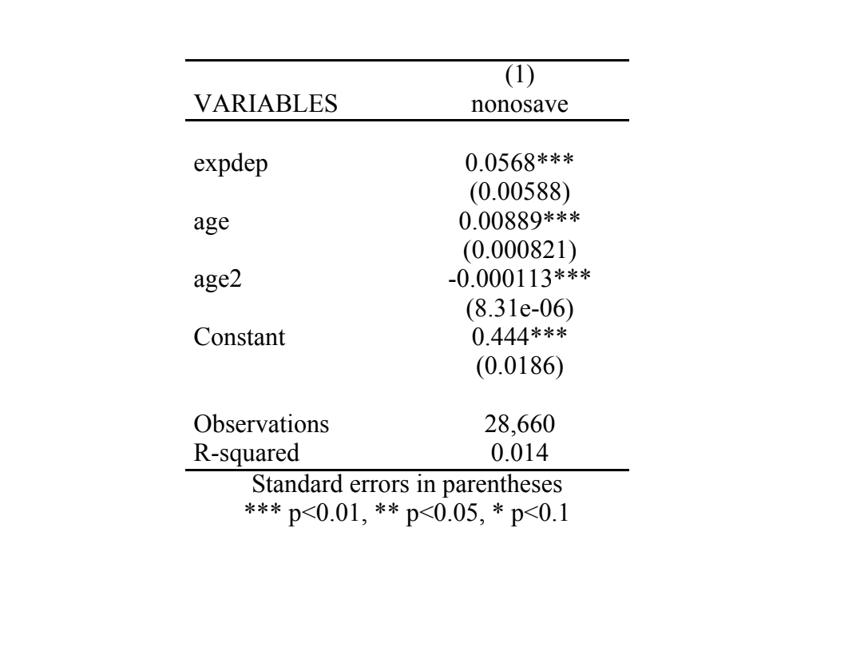



**Table 1**

**Results**

Data was input into Stata and a regression was applied. My analysis show a significant relationship (P<0.01) between experience of caregiving and intention to save. In fact, there was nearly an 8% increase in a person’s likelihood to save if they had previously been a caregiver (see Table 1). Interestingly, when regressed for age the results are quadratic with those in middle age more likely to express intention to save. This may be related to the fact that between the ages of 40 -50 people are more likely to have higher incomes and thus, have a greater amount of money they can save.

While I can only hypothesize on people’s intentions to save for retirement, I propose that the act of caring for an older person diminishes psychological distance by providing individuals with in depth details about the long term care process and thus, allowed the individual to mentally reconstruct their conception of retirement from abstract to concrete. In addition, it could be that caring for a loved one or family member allowed the individual to visualize what their future self might look like and thus, increase their saving behaviour as result.

**Limitations**

In this study,there are a number of limitations that should be noted when interpreting the results. Primarily, the variables I used were proxy measures and are based on a number of assumptions. Firstly, I assumed that people’s intention to save would align with people’s actual savings. Secondly, I used people’s experience of caregiving as a proxy for confronting their future self and diminishing psychological distance but due to the limits of time and access, I could not investigate if people in fact, do feel that temporal distance was diminished after caring for loved ones. In addition, a confounding factor in this data may be that those who are predisposed to save for retirement are more altruistic and save so as not to burden family members and thus, more likely to care for a loved one or family member.

**Policy Recommendations**

The population in the UK continues to age and will place increasing strain on social services unless, individuals increase their retirement savings. Traditional economics policies on retirement and long term have left decision making up to the individual. While behavioural economics has begun to initiate default retirement saving plans and nudge people into planning for their future. However, no current initiatives are in place that directly address the temporal distance that people may feel when thinking about retirement. Research on construal level theory has highlighted that emotional and highly visual communication of issues reduces psychological distance and increases people’s engagement with an issue (Spence, 2012). Therefore, I propose increasing visual representations of older population in media and through public health campaigns. Additionally, clear and concrete information should be given to individuals on retirement saving and long term care insurance when for instance, they make changes to their bank account. By ensuring people have the exact details of what they need to do, they are better equipped to make decisions about far future events and bridge psychological distance. Indeed, research has shown that presenting people with external concrete cues can shift people’s construal levels (Trope & Liberman, 2010).

**Conclusion**

As the population continues to age it is imperative that new policies and initiatives are developed that address how people save or engage with long term care. As seen above, being a caregiver or connecting with your future self can encourage individuals to increase saving behaviour. Based on this information, governments should focus on initiatives that help individuals reduce psychological distance between themselves and their future selves. This can include greater representation of older people in the media, tv adverts that allow people to visualize the concrete processes of ageing and retirement, or creating opportunities for volunteering or care giving in old age homes. However, due to the limitations of this study more research is needed to explore if the experience of caregiving does bridge psychological distance and accurately, evoke similar responses as seeing renditions of the future self.

**Bibliography (Topic 2)**

Andrews, R. et al., (2017). Positive Ageing Expectations Are Associated With Physical Activity Among Urban-Dwelling Older Adults. *The Gerontologist, 57(2)*, 178-186.

Apouey, B., (2018). Preparation for old age in France: The roles of preferences and expectations. *The Journal of the Economics of Ageing, 12*, 15-23.

Banks, J., & Oldfield, Z. (2007). Understanding pensions: Cognitive function, numerical ability and retirement saving. *Fiscal studies*, *28*(2), 143-170.

Bardach, S., Gayer, C., Clinkinbeard, T., Zanjani and J. Watkins. (2010). The Malleability of Possible Selves and Expectations Regarding Ageing. *Educational Gerontology, 36(5),* 407-424.

Benartzi, Shlomo and Richard Thaler (2007), Heuristics and Biases in Retirement Savings Behavior, *Journal of Economic Perspectives*, 21 (3), 81–104

Binswanger, Johannes and Katherine G. Carman (2009), How Real People Make Long-Term Decisions: The Case of Retirement Preparation, Tilburg University Discussion Paper 2009-73.

Chapman, Gretchen B. (1996), Temporal Discounting and Utility for Health and Money, *Journal of Experimental Psychology Learning Memory and Cognition*, 22 (3), 771–91.

Chipperfield, J. et al. (2018). A healthy dose of realism: The role of optimistic and pessimistic expectations when facing a downward spiral in health. *Social Science & Medicine*. 10.1016/j.socscimed.2018.08.030

Costa-Font, J. and M. Costa-Font, (2011.) Explaining Optimistic Old Age Disability and Longevity Expectations. Social Indicators Research, 104. 533-544.

English Longitudinal Study of Ageing (2017) *Wave 8* [Data file]. Retrieved from <https://www.elsa-project.ac.uk/>

Eurobarometer, S. (2007). Public opinion in the European Union.

Fujita K, Trope Y, Liberman N, Levin-Sagi M. Construal levels and self-control. Journal of personality and social psychology. 2006 Mar;90(3):351.

Finkelstein, A. and K. McGarry, K. (2003). *Private information and its effect on market equilibrium: New*

*evidence from long-term care insurance*. WP: National Bureau of Economic Research. 9957.

Goda GS, Levy MR, Manchester CF, Sojourner A, Tasoff J. The role of time preferences and exponential-growth bias in retirement savings. National Bureau of Economic Research; 2015 Aug 20.

Government Office for Science. Letwin, Rt Hon O., (2016.) GS/16/10/ Crown copyright.

Hershfield, H. E., Goldstein, D. G., Sharpe, W. F., Fox, J., Yeykelis, L., Carstensen, L. L., & Bailenson, J. N. (2011). Increasing saving behavior through age-progressed renderings of the future self. *Journal of Marketing Research*, *48*(SPL), S23-S37.

Kahneman, D. (2011). *Thinking, Fast and Slow.* Great Britain: Penguin Books Ltd.

Kotter-Gruhn, D., et al., (2009). Self-Perceptions of Ageing Predict Mortality and Change With Approaching Death: 16-Year Longitudinal Results From the Berlin Ageing Study. *Psychology and Ageing*, 24(3), 654-667.

Liberman N, Trope Y. The psychology of transcending the here and now. Science. 2008 Nov 21;322(5905):1201-5.

Liberman N, Trope Y, McCrea SM, Sherman SJ. The effect of level of construal on the temporal distance of activity enactment. Journal of Experimental Social Psychology. 2007 Jan 1;43(1):143-9.

McCrea SM, Liberman N, Trope Y, Sherman SJ. Construal level and procrastination. Psychological Science. 2008 Dec;19(12):1308-14.

Meisner, B. (2013). The relationship between ageing expectations and various modes of physical activity among ageing adults. *Psychology of Sport and Exercise,* *14*, 569-576.

Modigliani F. Life cycle, individual thrift, and the wealth of nations. Science. 1986 Nov 7;234(4777):704-12.

Office of National Statistics. (2015) *Life Expectancy at Birth and at Age 65 by Local Areas in England and Wales: 2012 to 2014*. Retrieved from <https://www.ons.gov.uk/peoplepopulationandcommunity/birthsdeathsandmarriages/lifeexpectancies/bulletins/lifeexpectancyatbirthandatage65bylocalareasinenglandandwales/2015-11-04>

Office of National Statistics. (2018) *Pensions, Savings, and Investments.*  Retrieved from <https://www.ons.gov.uk/peoplepopulationandcommunity/personalandhouseholdfinances/pensionssavingsandinvestments>

Pak, T. and Y. Choung. (2017.) Rationality of longevity expectations: Evidence from the Korean Longitudinal Study of Ageing. *Journal of Behavioural and Experimental Finance, 13*, 51-61.

Perez, A.M. et al. (2018). Influential Cognitive Processes on Framing Biases in Ageing. *Frontiers in Psychology,* 9 (661), doi: 10.3389/fpsyg.2018.00661

Pikhartova, J., Bowling, A., and C. Victor. (2016). Is loneliness in later life a self-fulfilling prophecy? *Ageing & Mental Health, 20(5)*, 543-549.

Prior, K. and K. Sargent-Cox. (2014). Students' expectations of ageing: An evaluation of the impact of imagined intergenerational contact and the mediating role of ageing anxiety. *Journal of Experimental Social Psychology*, 55, 99-104.

Rippon, I. and A. Steptoe. (2018.) Is the relationship between subjective age, depressive symptoms and activities of daily living bidirectional?. *Social Science & Medicine*, 214, 41-48.

Spence A, Poortinga W, Pidgeon N. The psychological distance of climate change. Risk Analysis: An International Journal. 2012 Jun;32(6):957-72.

Tennyson S, Yang HK. The role of life experience in long-term care insurance decisions. Journal of Economic Psychology. 2014 Jun 1;42:175-88.

Thaler, R.H. and C.R. Sunstein. (2009). *Nudge*. London: Penguin Books Ltd.

Thaler, Richard H. and Shlomo Benartzi (2004), “Save More Tomorrow: Using Behavioral Economics to Increase Employee Saving,” Journal of Political Economy, 112 (1), S164–S187.

Thorlby, Ruth, Anna Starling, Catherine Broadbent, and Toby Watt. "What’s the problem with social care, and why do we need to do better?."

Trope Y, Liberman N. Temporal construal. Psychological review. 2003 Jul;110(3):403.

Zhou‐Richter T, Browne MJ, Gründl H. Don't They Care? Or, Are They Just Unaware? Risk Perception and the Demand for Long‐Term Care Insurance. Journal of Risk and Insurance. 2010 Dec;77(4):715-47.